NATIONALITY WAIVER REQUEST FORM

JobsBank Posting (where required)

[Guidance to OREs: Please provide a screenshot of the posting. The screenshot should show the JobsBank ID, posting and closing dates as well as job description. The following is an example.]

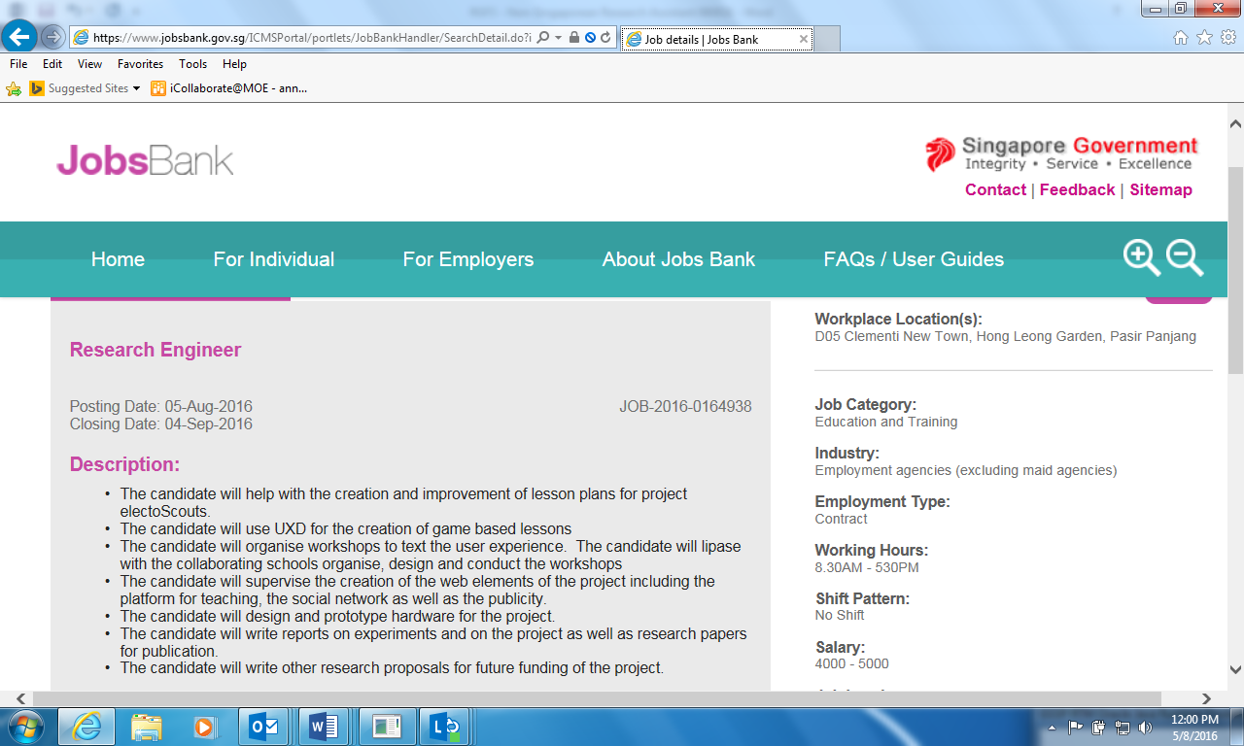

All hiring Institutions (Host or Partner) and the hiring supervisor PI/Co-Is/PM shall employ or otherwise engage Research Assistants/ Research Technicians or staff of equivalent qualifications who are Singapore citizens and/or Singapore Permanent Residents to be deployed in the work under the Research. Grantor’s prior approval is required before staff of other nationalities can be employed.

