NATIONALITY WAIVER REQUEST FORM

- JobsBank Posting (where required)

[Guidance to OREs: Please provide a screenshot of the posting. The screenshot should show the JobsBank ID, posting and closing dates as well as job description. The following is an example.]

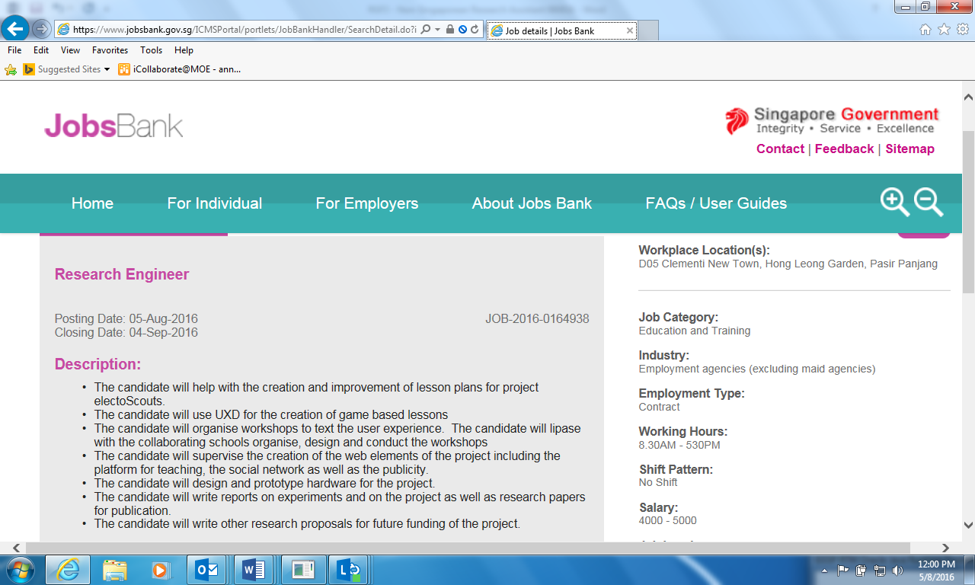

- Details of Unsuccessful Singaporean/Permanent Resident applicants:

S/N | Applicant Name | Academic Background  *please state discipline & specialization and highest qualification attained | Decision | Reasons for not interviewing/selecting SC/PR applicant
 | [Please add more rows where necessary]

* Grantor may request for CVs of any Singaporean/PR applicants for the JobsBank posting and these must be provided if requested.

All hiring Institutions (Host or Partner) and the hiring supervisor PI/Co-Is/PM shall employ or otherwise engage Research Assistants/ Research Technicians or staff of equivalent qualifications who are Singapore citizens and/or Singapore Permanent Residents to be deployed in the work under the Research. Grantor’s prior approval is required before staff of other nationalities can be employed.

