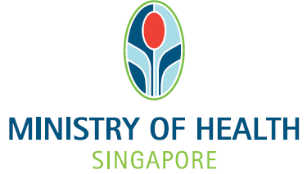

National Medical Research Council
nGager Training and User Guide (Resubmission after RD/ RDO Commented)
Version 3.0

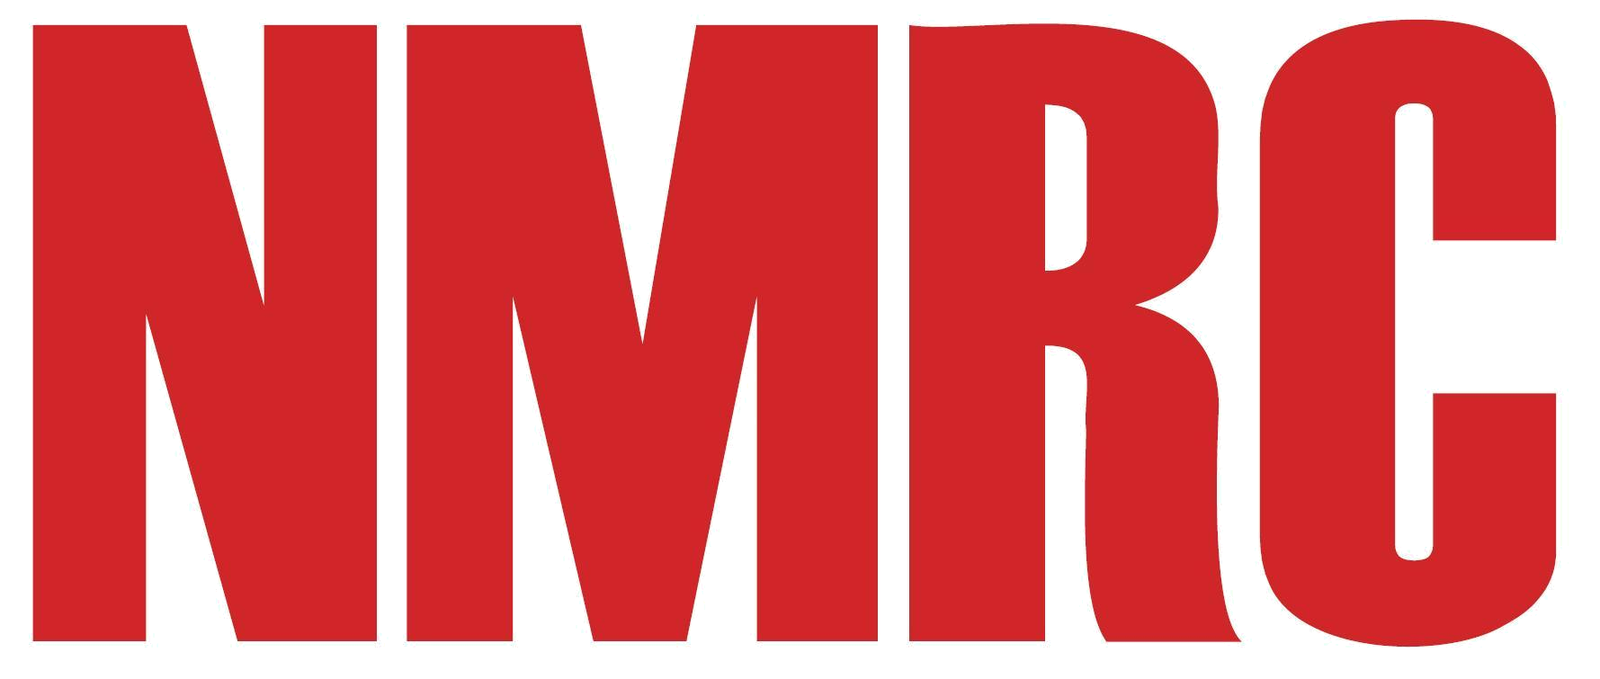

Table of Contents
1.1 RETURN APPLICATION TO PI FROM HOST INSTITUTION 1
1.1.1 Pending Revision 1

RETURN APPLICATION TO PI FROM HOST INSTITUTION
After a grant application has been submitted, it will be viewed by the RD and RDO from the Host Institution for recommendation(s) and endorsement. If the RD or RDO requires the PI to update his/her application, they are able to key in recommendations and return the application to the PI.

Pending Revision
If a grant application has been returned by the HI’s RDO/RD, PI will receive a notification email and the status of this grant application will be ‘Pending Revision’.

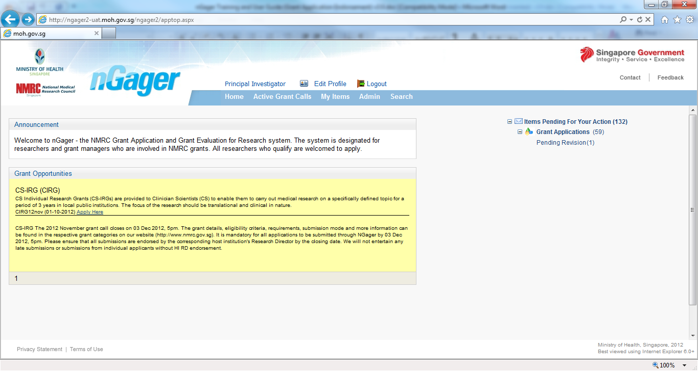

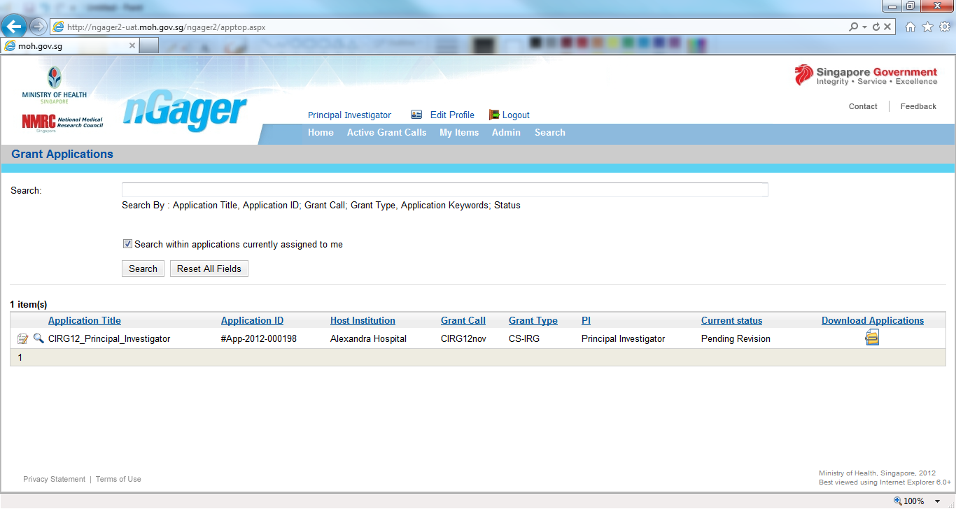
- Open the application you wish to revise (Click on the Edit Icon).

PI needs to go through the whole application to review and revise its’ details

- Check which section(s) need revision (Your HI’s RD/RDO should have made comments on the section(s) which need revision)
- For each applicable section
  - Select the tab
  - Update the information
  - Click the Save button

Once the required sections have been updated, PI needs to ‘Submit’ it once ready. Your application will be routed back to the RDO/RD and its’ status will now be ‘Pending HI Endorsement’.

