

National Medical Research Council
nGager Training and User Guide (Comment and Return Application to PI)
Version 3.0

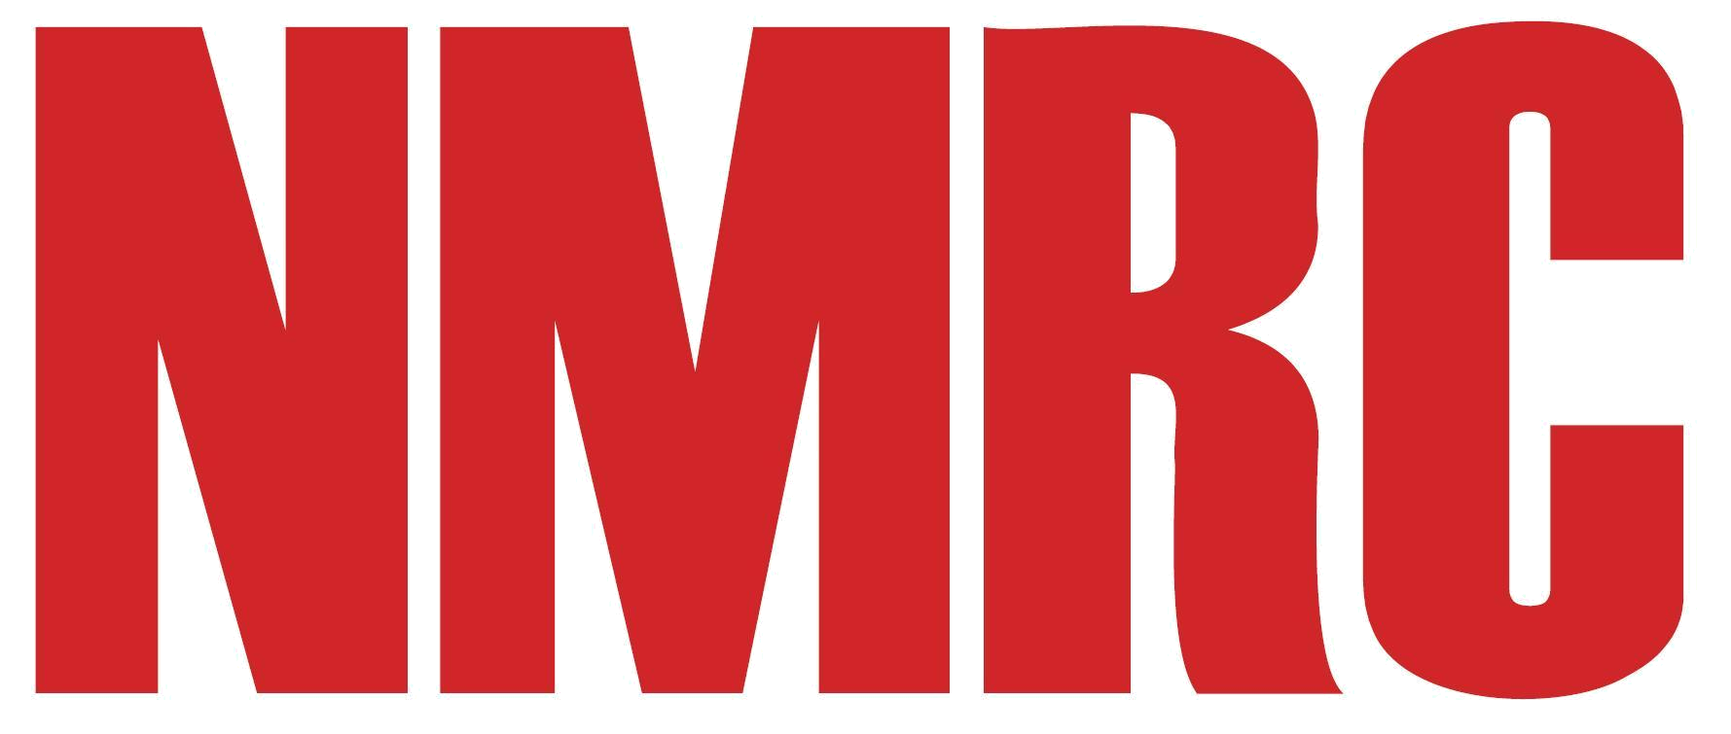

Table of Contents
1.1.1 Return an application to PI by RDO 1
1.1.2 Return an application to PI by RD 3

When the Principal Investigator has created a draft grant application and the Host Institution has been selected, Research Director and Research Development Officer from the Host Institution can view the Draft version of the grant application, which is in read-only mode.

Return an application to PI by RDO
To provide a comment/recommendation:
- Select ‘Grant Applications > Pending HI Endorsement’ in the navigation menu

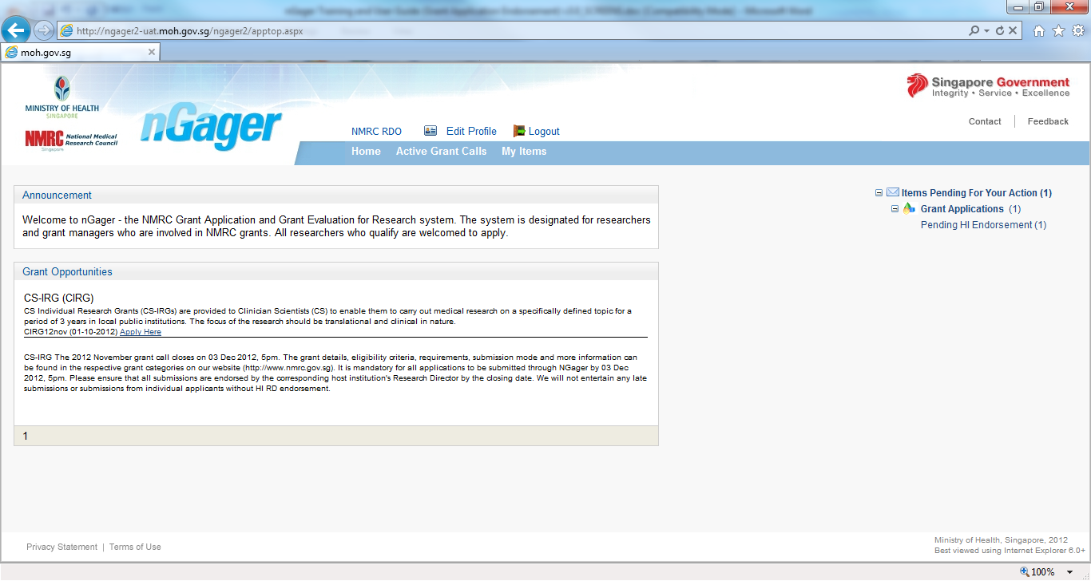
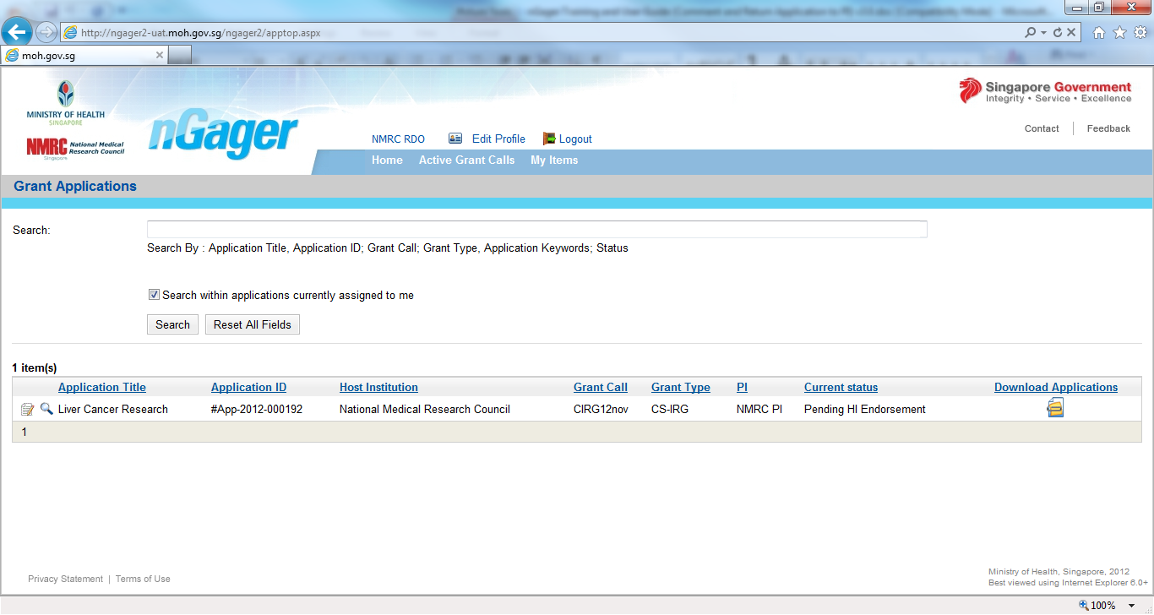
- Click on the icon [] link for the specific application

To add comments to a specific application tab:
- Select the tab
- Key in your comment under the ‘RDO Comment’ section. (this is available in all sections in the application)

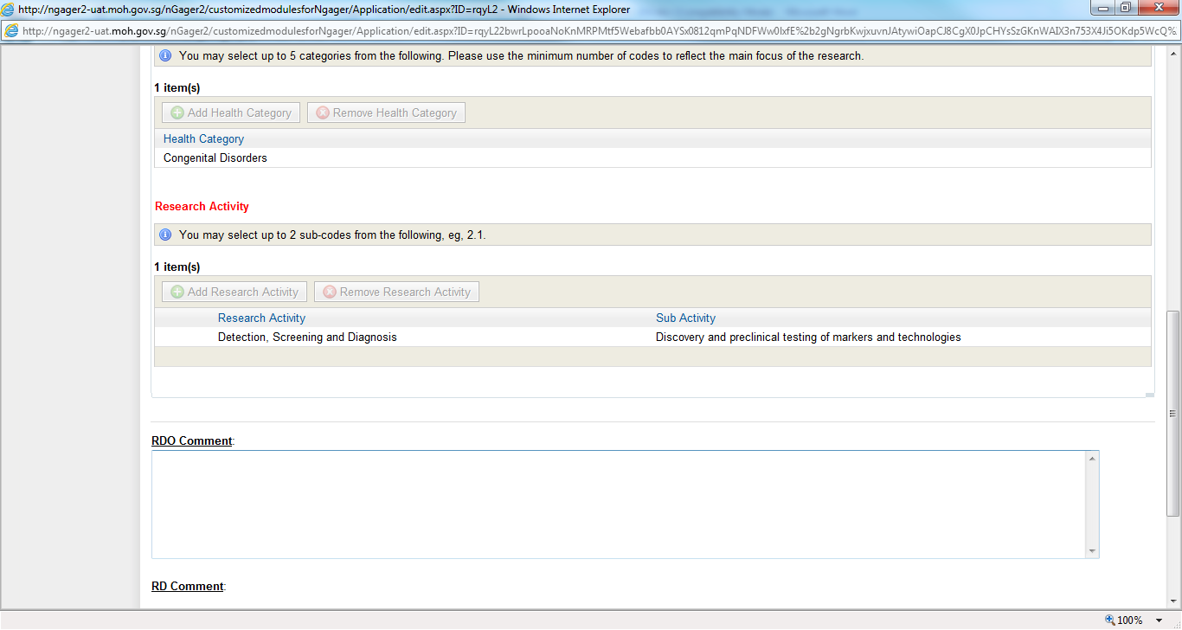
- Click the Save button

IMPT: Once all comments have been added:

- Select the HI’s Comments tab and type in a Message to the PI. Please inform the PI which tabs/sections you have made comments in. (For eg: if you made comments in the ‘Abstract’ tab, do inform the PI to view the ‘Abstract’ tab for your comments)

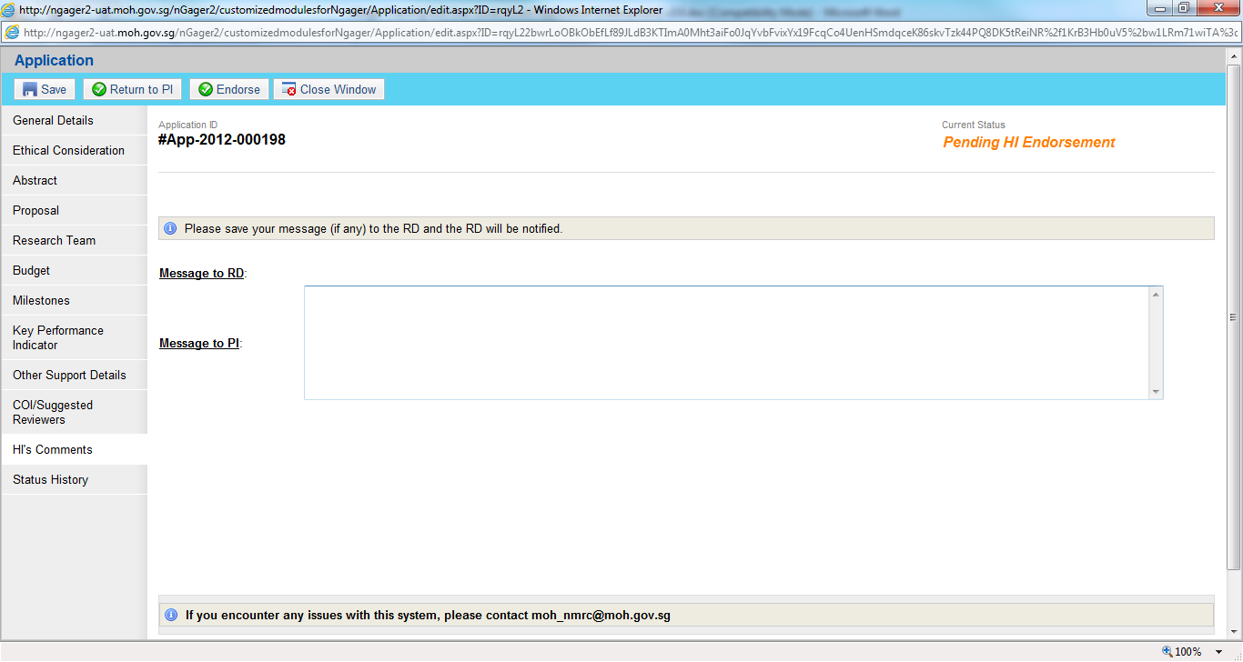
- Click the Save button
After all comments have been added, if the Grant Application needs some more updates by PI, RDO can return it to PI.

- Select ‘Return to PI’ to send the Grant Application back to PI to update and resubmit.
- Click on ‘Save’ Button.

Note: If RDO returns to PI, RD will not be able to see ‘[Pending HI Endorsement]’ task. RD can only see the Grant Application with the status ‘Draft (Returned from RDO)’.

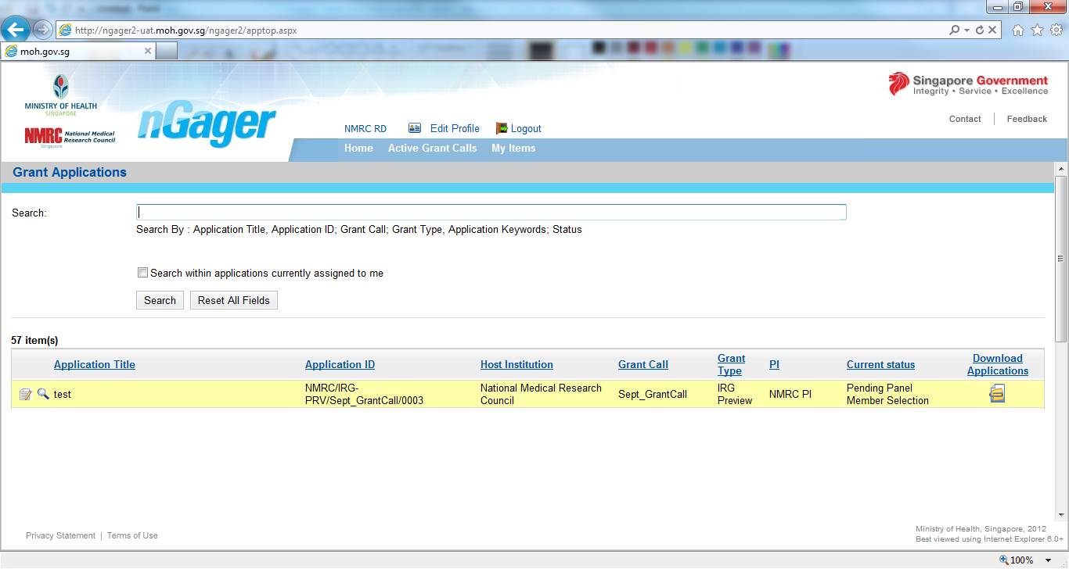

Return AN APPLICATION to PI by RD

Once the Research Development Officer has made their recommendations/comments, the Research Director will be able to view these recommendation/comments when he/she views the application.

NOTE: The Research Director does not have to wait for the Research Development Officer’s recommendations and can give their endorsement to the application at any time.

To provide recommendations/comments:
- Select ‘Grant Applications > Pending HI Endorsement’ in the home menu
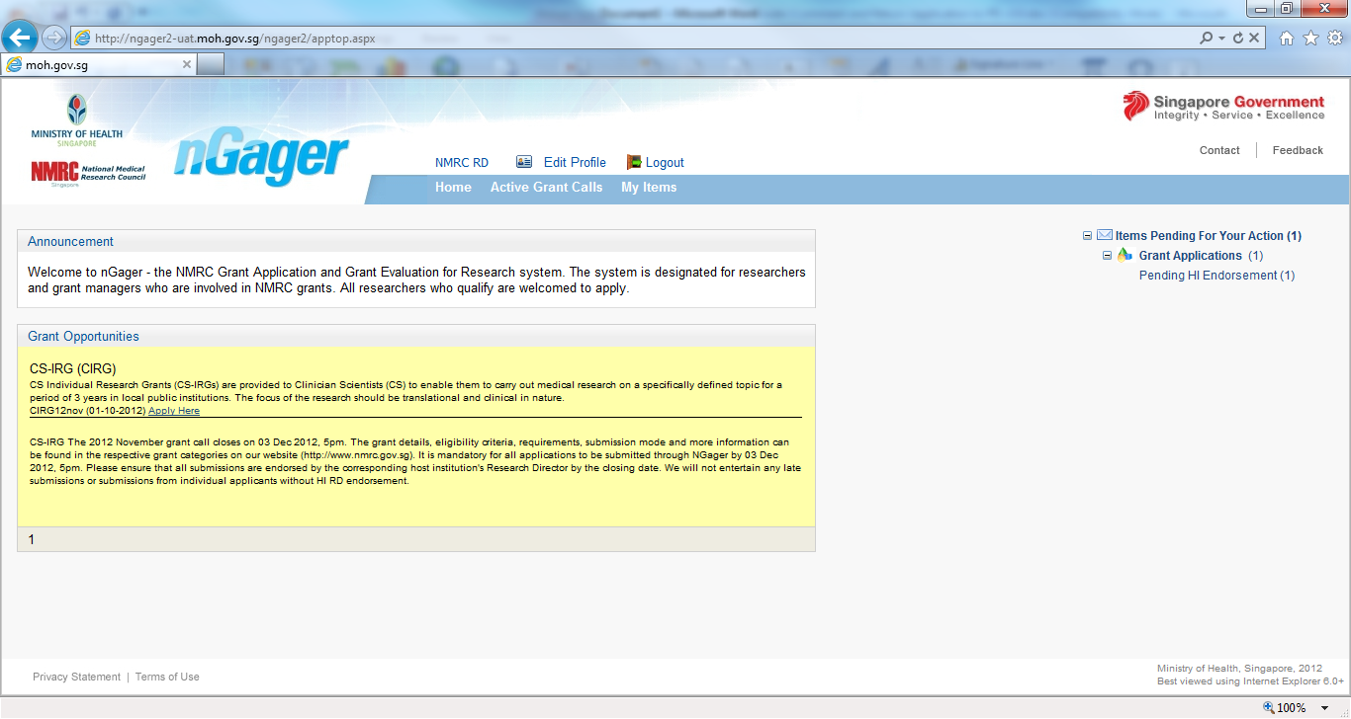
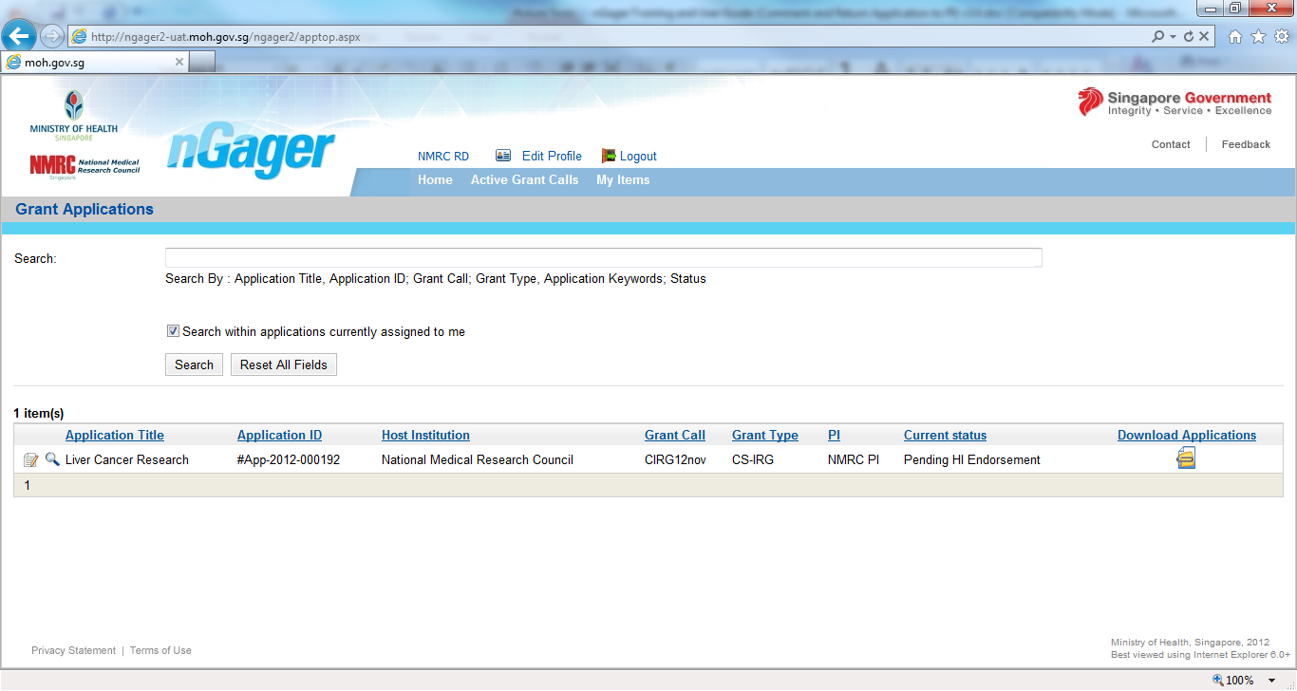
- Click on the icon [] link for the application you wish to view.

To add comments to a specific application tab:
- Select the tab you wish to comment on
- Key in your comment under the ‘RD Comment’ section. (this is available in all sections in the application)

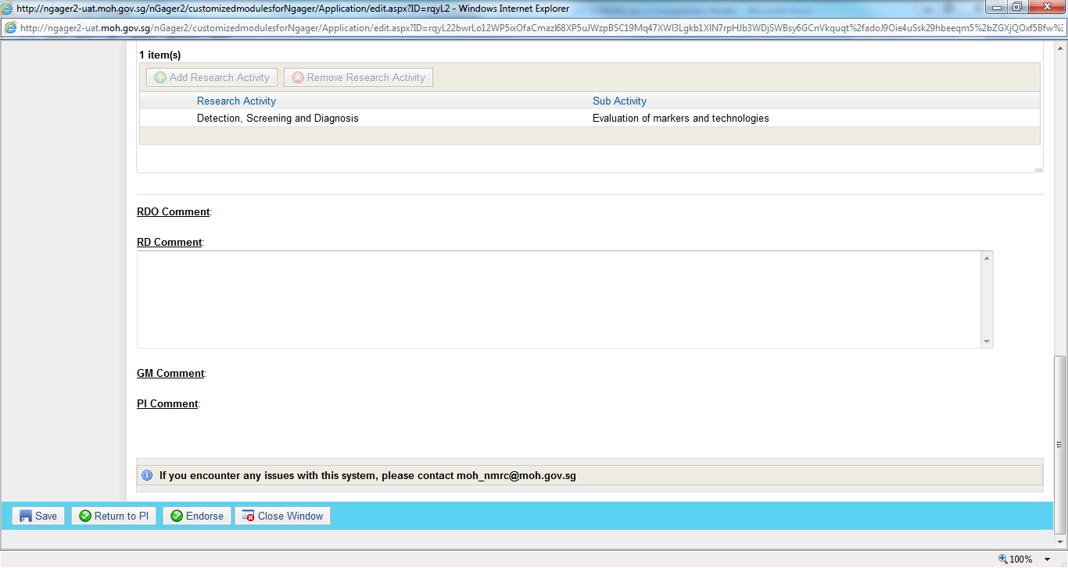

- Click the Save button

IMPT: Once all comments have been added:

- Select the HI’s Comments tab and type in a Message to the PI. Please inform the PI which tabs/sections you have made comments in. (For eg: if you made comments in the ‘Abstract’ tab, do inform the PI to view the ‘Abstract’ tab for your comments)

- Click the Save button
- Click the [Return to PI] button to send it back to the PI for changes.

Note: If RD returns the application to PI, RDO will not be able to see ‘[Pending HI Endorsement]’ task. RDO can only see Grant Application with the status ‘Draft (Returned from RD)’. Draft Applications are available in read-only mode for RD/RDOs

