NATIONALITY WAIVER REQUEST FORM

Award Number
Funding Scheme | (e.g. CS-IRG, OF-LCG, OF-IRG, OF-YIRG)
Project/ProgrammeTitle
Full Name of Lead Principal Investigator (PI)/
Centre/Institution/Cluster Head (for Centre Grant)
Host Institution
Faculty & Department
Project/Programme Start Date & End Date
(dd/mm/yyyy - dd/mm/yyyy)
Date of Request (dd/mm/yyyy)

Mandatory Supporting Documents*:
☐ Posting at Jobs Bank
(Host Institution should ensure that the job is posted at Jobs Bank for a reasonable timeframe before seeking NMRC’s waiver)
☐ CV of the proposed non-Singaporean/Permanent Resident (SC/PR) candidate

Job Description:

Details of Unsuccessful Singaporean/Permanent Resident applicants:
S/N | Applicant Name | Academic Background  *please state discipline & specialization and highest qualification attained | Decision | Reasons for not interviewing/selecting SC/PR applicant
 | [Please extend table where necessary]

* Grantor may request for CVs of any Singaporean/PR applicants for the JobsBank posting and these must be provided if requested.

Justification for Waiver Request:

Declaration by Lead Principal Investigator/ Principal Investigator – applicable to project/ thematic grants; for Centre Grant, please use the below

I declare that all the above information provided is true and have complied with the MOM’s Fair Consideration Framework and the host institution’s HR policies.

Signature of Lead Principal Investigator |  | Date

Declaration by Institution Head – applicable to Centre Grant only

I declare that all the above information provided is true and have complied with the MOM’s Fair Consideration Framework and the host institution’s HR policies.

Signature of Centre/ Institution/ Cluster Head or his/ her designated authority |  | Date

Endorsement by Director, Office of Research or Equivalent

Please comment on whether the request is reasonable and within the guidelines and policies of the host institution.

Name & Signature of Director, Office of Research/ or equivalent |  | Date

Enclosure 1

JobsBank Posting

[Guidance to OREs: Please provide a screenshot of the posting. The screenshot should indicate the posting and closing dates as well as job description. The following is an example.]

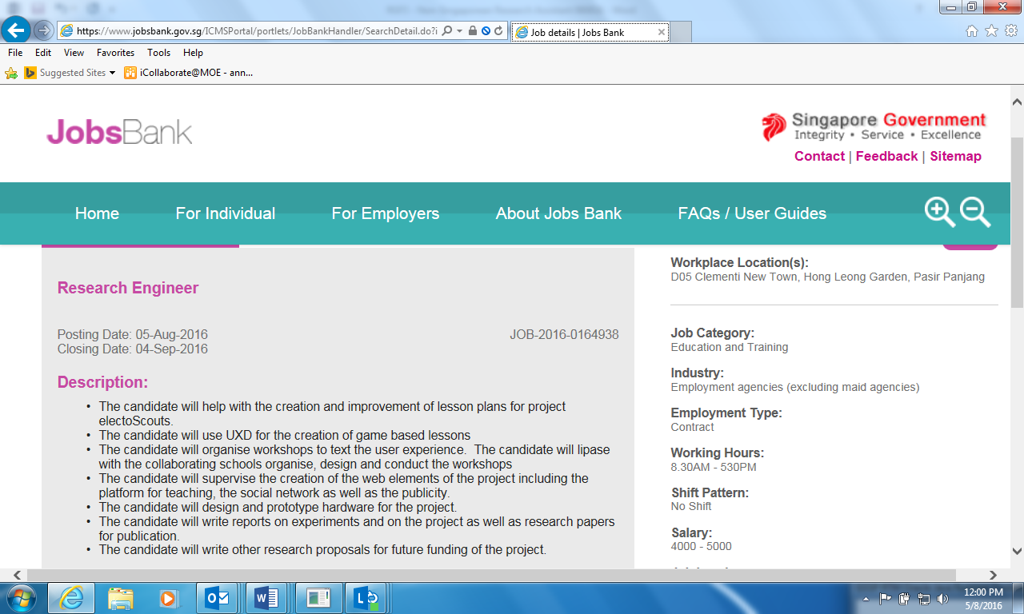

Enclosure 2

CV of Proposed non-Singaporean/Permanent Resident (SC/PR) Candidate
[Guidance to OREs: This should generally be no more than 3 pages]

All hiring Institutions (Host or Partner) and the hiring supervisor PI/Co-Is/PM shall employ or otherwise engage Research Assistants/ Research Technicians or staff of equivalent qualifications who are Singapore citizens and/or Singapore Permanent Residents to be deployed in the work under the Research. Grantor’s prior approval is required before staff of other nationalities can be employed.
For each candidate, please send the completed file together with the mandatory supporting documents in a single pdf file. Each pdf file must be no more than 0.5 mb.

